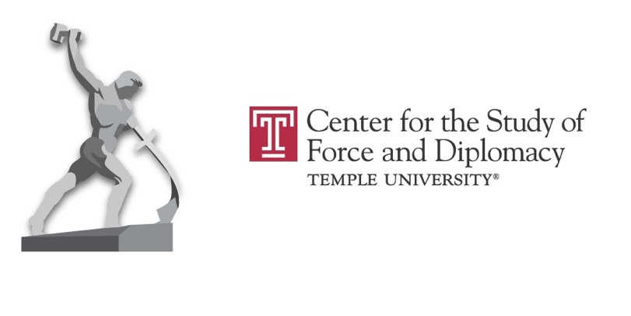

2025 Spring CENFAD Video Lectures

**David Suisman**, University of Delaware, author of[Instrument of War: Music and the Making of America's Soldiers](https://temple.hosted.panopto.com/Panopto/Pages/Viewer.aspx?id=3d2de6aa-00cf-4ebf-99be-b26e0162dd46)

(<https://temple.hosted.panopto.com/Panopto/Pages/Viewer.aspx?id=3d2de6aa-00cf-4ebf-99be-b26e0162dd46> )

Although music has been part of war since time immemorial, its significance has rarely received serious critical analysis. Focusing on the United States, David Suisman will trace how the American military used—and continues to use—music to train soldiers and regulate military life, and how soldiers themselves have turned to music to cope with war’s emotional and psychological strains. From boot camp to the battlefield, from brass bands to iPods, music has coursed through American war-making from the Civil War to the twenty-first century. This talk will illuminate the ways music has functioned as a lubricant in the American war machine.

David Suisman is associate professor of history at the University of Delaware specializing in cultural history, war and society, and the history of capitalism. He is the author of *Instrument of War: Music and the Making of America’s Soldiers* (University of Chicago Press, 2024) and the award-winning *Selling Sounds: The Commercial Revolution in American Music* (Harvard University Press, 2009). He is co-editor of *Capitalism and the Senses* (University of Pennsylvania Press, 2023) and *Sound in the Age of Mechanical Reproduction* (University of Pennsylvania Press, 2010). His articles have appeared in the *Journal of American History*,*Social Text*, *Radical History Review, Journal of Social History,*and other publications. From 2009 to 2020, he was coordinator of the Hagley Program in the History of Capitalism, Technology, and Culture.

## **Kate Epstein**, University of Rutgers-Camden, author of *Analog Superpowers: How Twentieth-Century Technology Theft Built the National Security State*

## **No recording available**

**Iva Sidash**, Visual Storyteller, based in Ukraine,[Conflict Photography - Stories Behind the Lens - Personal Experience in Documenting War](https://temple.hosted.panopto.com/Panopto/Pages/Viewer.aspx?id=35f66374-23d0-4821-9b00-b287016298f0)

(<https://temple.hosted.panopto.com/Panopto/Pages/Viewer.aspx?id=35f66374-23d0-4821-9b00-b287016298f0>)

This lecture examines the personal nature of documenting conflict through the lens of a photographer. Iva Sidash shares her experience of living and working in war zones, discussing the technical, ethical, and emotional challenges she faces. She highlights how war is not just a global event, but a series of intimate, human stories—captured through moments of pain, survival, and resilience. The lecture explores how these personal connections shape her work and the approach to telling complex, transparent stories in such sensitive environments. Iva Sidash is an independent photographer and visual storyteller based in Ukraine. She is a member of the Ukrainian Association of Professional Photographers and the National Society of Photo Artists in Ukraine. In 2023-2024 Sidash studied Documentary Practices and Visual Journalism at the International Center of Photography in New York. Since Russia’s full-scale invasion of Ukraine, Sidash has focused on capturing both the visit effects of the war and the often overlooked, personal stories of those affected. Her photography merges art and documentary approaches, bringing attention to the human experiences shaped by war.

Sidash is the recipient of numerous awards and fellowships, including the Ian Parry Grant (2024), Chris Hondros Fellowship (2024) and the Women Photograph Fellowship (2024). Her work has been published in The Atlantic, INSIDER, The Financial Times, The Fisheye Magazine, Der Speigel, Forbes, and Bird in Flight.

**Osamah Khalil**, Syracuse University, author of

[A World of Enemies: America's Wars at Home and Abroad from Kennedy to Biden](https://temple.hosted.panopto.com/Panopto/Pages/Viewer.aspx?id=f54a91eb-27cd-459d-8f1e-b29f0152db2e)

(<https://temple.hosted.panopto.com/Panopto/Pages/Viewer.aspx?id=f54a91eb-27cd-459d-8f1e-b29f0152db2e>)

In *A World of Enemies: America's Wars at Home and Abroad from Kennedy to Biden*(Harvard University Press, 2024), Professor Osamah Khalil examines the relationship between domestic politics and policy and U.S. foreign policy over six decades. He traces the intersections of the wars on crime, drugs, and terror from the Vietnam War era to the present. Khalil’s book talk will focus on how the U.S. applied the rhetoric of civilization and barbarism to American cities and conflict zones overseas.

Dr. Osamah F. Khalil is a Professor of History at Syracuse University’s Maxwell School of Citizenship and Public Affairs. He is the author of *A World of Enemies: America's Wars at Home and Abroad from Kennedy to Biden*(Harvard University Press, 2024)and *America’s Dream Palace: Middle East Expertise and the Rise of the National Security State* (Harvard University Press, 2016), which was named a Best Book of 2017 by *Foreign Affairs*. He is also the editor of *United States Relations with China and Iran: Toward the Asian Century*(Bloomsbury Press, 2019). Dr. Khalil is a graduate of Temple University (B.A., 1994) and is a frequent media commentator and contributor for local, national, and international media outlets.

Tuesday, March 25: **Michael Kimmage**, Catholic University, *Collisions: The Origins of the War in Ukraine and the New Global Instability*

Friday, April 4: **Samuel Moyn**, Yale University, “*Making War Humane*”

Monday, April 7: **Heather Venable**, U.S. Air Force, “Flying into the Future: The Role of Airpower in Today and Tomorrow’s Warfare”